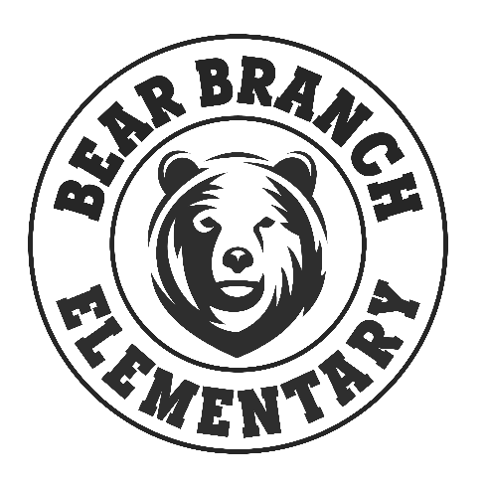

SPIRIT SHIRT ORDER FORM
2021-2022

Name: ______________________________________________________

Email: ______________________________________________________

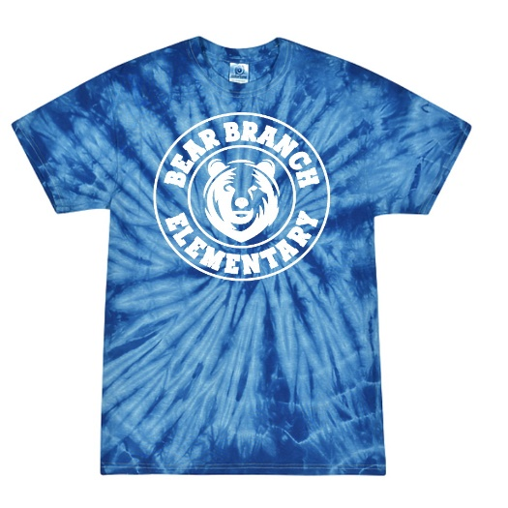
(Shirts are royal blue tie dye with white logo)
Shirts are $20.00 each

Please enter quantity:

____ Youth XS ____ Youth S ____ Youth M ____ Youth L

____ Youth XL ____ Adult S ____ Adult M ____ Adult L

____ Adult XL ____ Adult XXL ____ Adult XXXL

# of shirts: ________ Total Price: ________

MAKE CHECKS PAYABLE TO BBES PTO

Thank you for supporting BBES!
Questions: bbesptoinfo@gmail.com

